**Question 1**

The following is a list of 10 students ages: ages = [19, 22, 19, 24, 20, 25, 26, 24, 25, 24] • Sort the list and find the min and max age • Add the min age and the max age again to the list • Find the median age (one middle item or two middle items divided by two) • Find the average age (sum of all items divided by their number) • Find the range of the ages (max minus min)

**Source Code:**

ages = [19, 22, 19, 24, 20, 25, 26, 24, 25, 24]#initialisation of list

print(min(ages),max(ages))#function for finding minimum and maximumages

ages.append(19)#function for adding number to the list

ages.append(26)#function for addding number to the list

print(ages)#function for finding list

import statistics

ages = [19, 22, 19, 24, 20, 25, 26, 24, 25, 24, 19, 26]

print("Median of data-set is : % s " % (statistics.median(ages)))#function for finding median of ages

ages = [19, 22, 19, 24, 20, 25, 26, 24, 25, 24, 19, 26]

avg = sum(ages)/len(ages)

print("The average is ", round(avg,2))#function for finding average of ages

x = range(19,27)

for n in x:

print(n)#Printing range of ages

**output:**

19 26

[19, 22, 19, 24, 20, 25, 26, 24, 25, 24, 19, 26]

Median of data-set is : 24.0

The average is 22.75

19

20

21

22

23

24

25

26

Process finished with exit code 0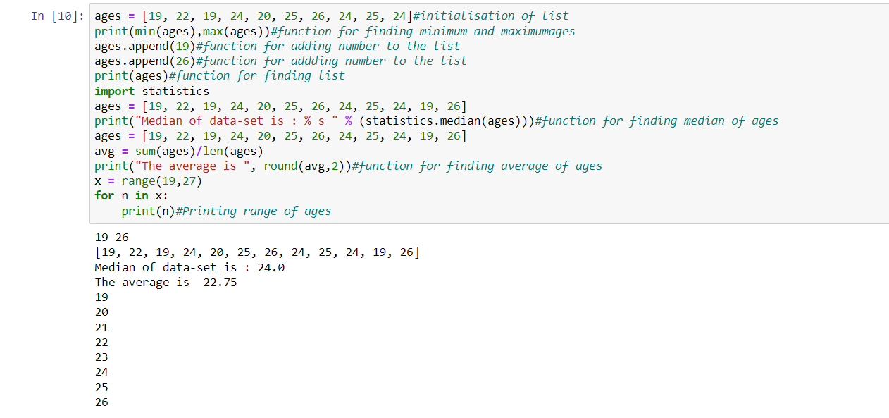

**Question 2**

• Create an empty dictionary called dog • Add name, color, breed, legs, age to the dog dictionary • Create a student dictionary and add first_name, last_name, gender, age, marital status, skills, country, city and address as keys for the dictionary • Get the length of the student dictionary • Get the value of skills and check the data type, it should be a list • Modify the skills values by adding one or two skills • Get the dictionary keys as a list • Get the dictionary values as a list

Source code:

dog={} #function for creating empty dictionary

dog['name']= 'bull dog'#function for adding name

dog['color']= 'black'#function for adding colour

dog['breed']= 'american breed'#function for adding breed

dog['legs']=4 #function for adding legs

dog['age']=10 #function for adding age

student=dict() #function for creating dictinory

student['first_name']='lucky'

student['last_name']= 'great'

student['gender']='Male'

student['age']=21

student['Marital_status']='No'

student['skills']=['C','c++','Python']

student['country']='India'

student['city']='banglore'

student['address']= 'xyz colony'

print(student) ##function for printing student dictinory

len_of_student= len(student)

print(len_of_student)# #function for printing lenth of student dictinory

skills_of_student= student.get('skills')

print(skills_of_student)

print(type(skills_of_student))#function for printing skills of student

student.update({'skills':['C','c++','Python','java','cobal']})

print(student)

student_keys= list(student.keys())

print(student_keys)#function for printing student keys

student_values= list(student.values())

print(student_values)#function for printing student values

**output:**

{'name': 'bull dog', 'color': 'black', 'breed': 'american breed', 'legs': 4, 'age': 10}

{'first_name': 'lucky', 'last_name': 'great', 'gender': 'Male', 'age': 21, 'Marital_status': 'No', 'skills': ['C', 'c++', 'Python'], 'country': 'India', 'city': 'banglore', 'address': 'xyz colony'}

9

['C', 'c++', 'Python']

<class 'list'>

{'first_name': 'lucky', 'last_name': 'great', 'gender': 'Male', 'age': 21, 'Marital_status': 'No', 'skills': ['C', 'c++', 'Python', 'java', 'cobal'], 'country': 'India', 'city': 'banglore', 'address': 'xyz colony'}

['first_name', 'last_name', 'gender', 'age', 'Marital_status', 'skills', 'country', 'city', 'address']

['lucky', 'great', 'Male', 21, 'No', ['C', 'c++', 'Python', 'java', 'cobal'], 'India', 'banglore', 'xyz colony']

Process finished with exit code 0

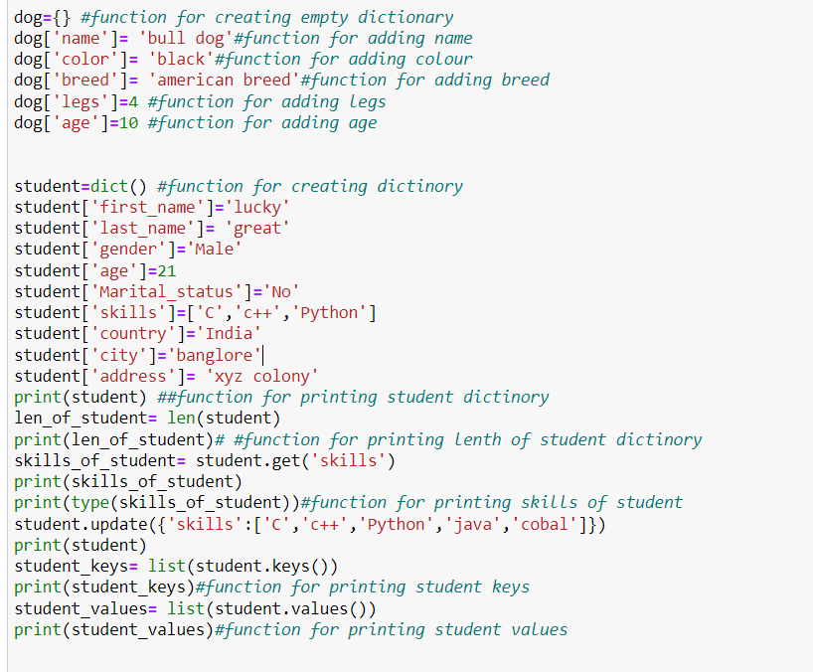

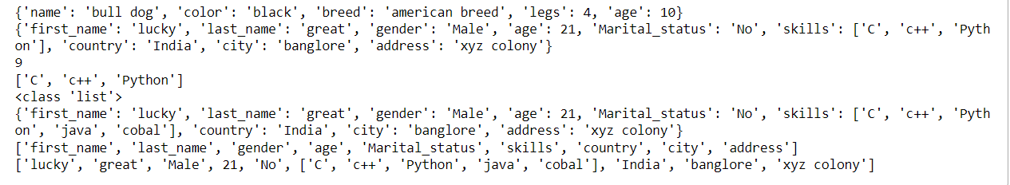

**QUESTION 3**

• Create a tuple containing names of your sisters and your brothers (imaginary siblings are fine) • Join brothers and sisters tuples and assign it to siblings • How many siblings do you have? • Modify the siblings tuple and add the name of your father and mother and assign it to family_members

Source Code:

**SOURCE CODE:**

sisters=('ammu','bhavi','sweety')#creating a tuple

brothers=('rahul','mahi','sai')

siblings= sisters+ brothers#joining sister_tuple and brother_tuple using addition operator

print(siblings)

siblings_count=len(siblings)#function for getting length of the siblings

print(siblings_count)

temp_siblings=list(siblings)#using temp function

temp_siblings.extend(['raki','leon'])#using extend function

family_members=tuple(temp_siblings)

print(family_members)#printing family members to get a list

**output:**

('ammu', 'bhavi', 'sweety', 'rahul', 'mahi', 'sai')

6

('ammu', 'bhavi', 'sweety', 'rahul', 'mahi', 'sai', 'raki', 'leon')

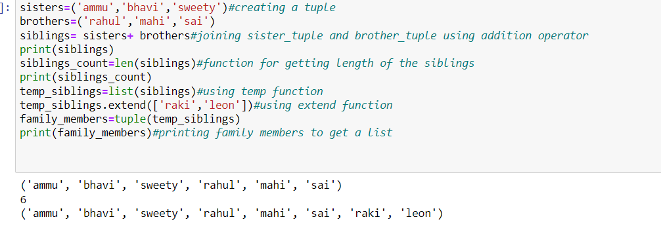

**Question 4**

it_companies = {'Facebook', 'Google', 'Microsoft', 'Apple', 'IBM', 'Oracle', 'Amazon'} A = {19, 22, 24, 20, 25, 26} B = {19, 22, 20, 25, 26, 24, 28, 27} age = [22, 19, 24, 25, 26, 24, 25, 24] • Find the length of the set it_companies • Add 'Twitter' to it_companies • Insert multiple IT companies at once to the set it_companies • Remove one of the companies from the set it_companies • What is the difference between remove and discard • Join A and B • Find A intersection B • Is A subset of B • Are A and B disjoint sets • Join A with B and B with A • What is the symmetric difference between A and B • Delete the sets completely • Convert the ages to a set and compare the length of the list and the set.

**Source code:**

it_companies = {'Facebook', 'Google', 'Microsoft', 'Apple', 'IBM', 'Oracle', 'Amazon'}

len_of_it=len(it_companies)#using length function

it_companies.add('Twitter')

print(it_companies)#using print function to get the list of it companies

it_companies.update({'wipro','infosys','Tesla'})

print(it_companies)

it_companies.remove('Microsoft')#using remove function

print(it_companies)

#The built-in method, discard () in Python, removes the element from the set only if the element is present in the set. If the element is not present in the set, then no error or exception is raised and the original set is printed.

A = {19, 22, 24, 20, 25, 26}#intilializing sets

B = {19, 22, 20, 25, 26, 24, 28, 27}

C=A.union(B)

print(C)

A_inter_B= A.intersection(B)

print(A_inter_B)

subset_check= A.issubset(B)

print(subset_check)

#As the function is subset() return true A is a Subset of B)

disjoint_check= A.isdisjoint(B)

print(disjoint_check)

E=A.union(B)

D= B.union(A)

print(E)

print(D)

#using delete function to delete the sets

del A

del B

del C

del D

del E

age = [22, 19, 24, 25, 26, 24, 25, 24]

len_age=len(age)

age_set=set(age)

len_age_set=len(age_set)

diff_age= len_age-len_age_set

print(diff_age)

**output:**

{'Google', 'Amazon', 'IBM', 'Oracle', 'Twitter', 'Facebook', 'Microsoft', 'Apple'}

{'Google', 'infosys', 'IBM', 'Tesla', 'Twitter', 'Facebook', 'wipro', 'Microsoft', 'Oracle', 'Amazon', 'Apple'}

{'Google', 'infosys', 'IBM', 'Tesla', 'Twitter', 'Facebook', 'wipro', 'Oracle', 'Amazon', 'Apple'}

{19, 20, 22, 24, 25, 26, 27, 28}

{19, 20, 22, 24, 25, 26}

True

False

{19, 20, 22, 24, 25, 26, 27, 28}

{19, 20, 22, 24, 25, 26, 27, 28}

3

Process finished with exit code 0

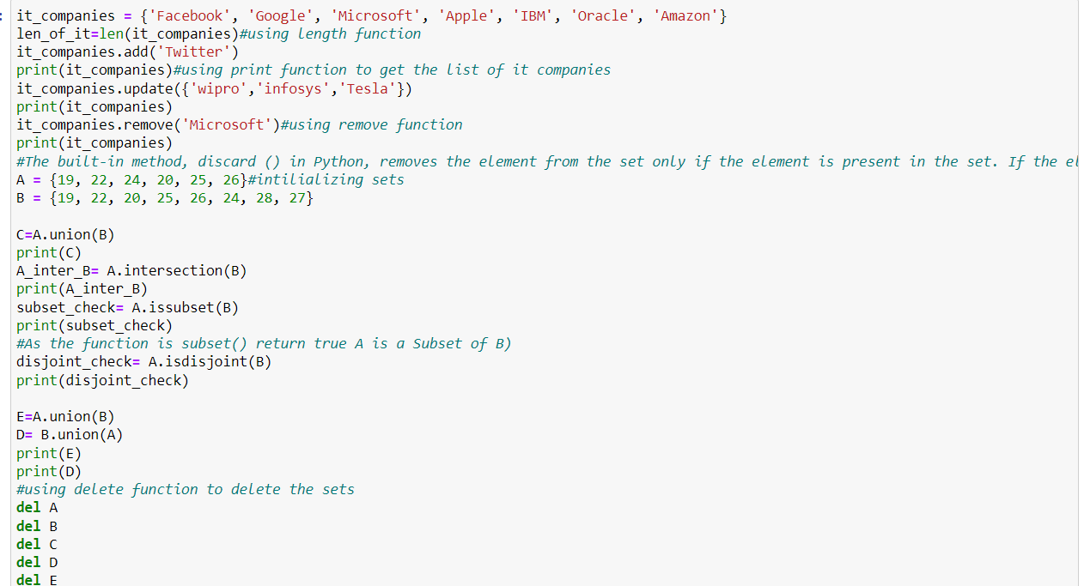

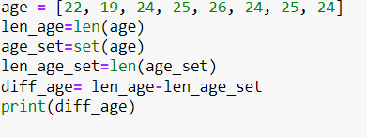

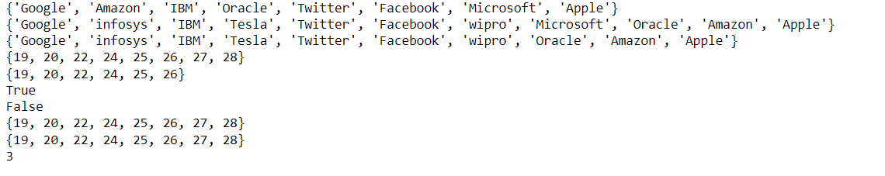

**Question 5**

The radius of a circle is 30 meters. • Calculate the area of a circle and assign the value to a variable name of _area_of_circle_ • Calculate the circumference of a circle and assign the value to a variable name of _circum_of_circle_ • Take radius as user input and calculate the area.

**Source code:**

phi = 3.14

g=30

radius = float(input())

def Area(r):# using def function for defining area

_area_of_circle_ = phi * r**2

print("Area of the given radius is %s" %_area_of_circle_)#using print function to get the area of given radius

Area(radius)

def circumferance(t):using def function for defining circumferance

_circum_of_circle_ = 2 * phi *t

print("circumferance",_circum_of_circle_)

circumferance(radius)

Area(g)

circumferance(g)

**output:**

15

Area of the given radius is 706.5

circumferance 94.2

Area of the given radius is 2826.0

circumferance 188.4

Process finished with exit code 0

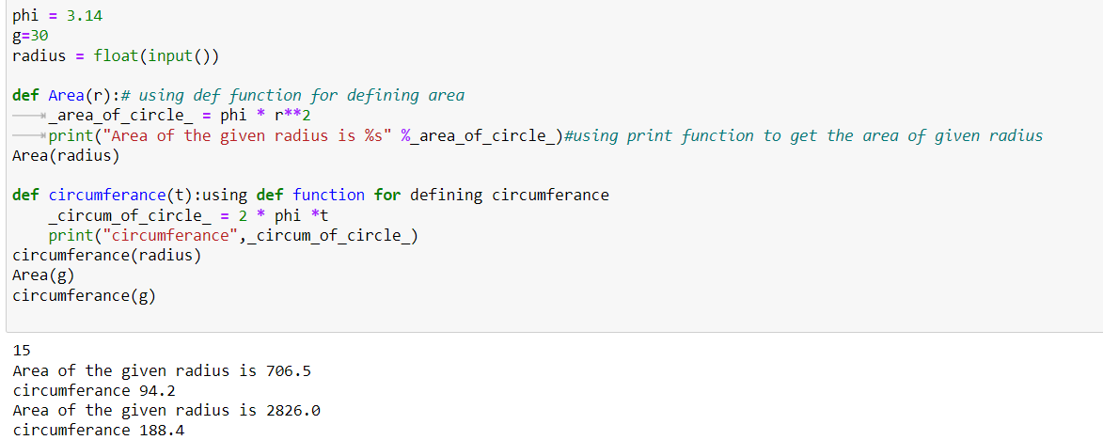

**Question 6**

“I am a teacher and I love to inspire and teach people” • How many unique words have been used in the sentence? Use the split methods and set to get the unique words.

**Source code:**

str="I am a teacher and I love to inspire and teach people"

print(type(str)) #using type function to get the data

y=str.split() #using split function for spliting the words

print(y)

set_str=set(y) #adding the split words into set

print(set_str)

print("no:- of unique words in given sentence is %s" % len(set_str)) #as set doesnt take duplicate keys we can directly find the length

**output:**

<class 'str'>

['I', 'am', 'a', 'teacher', 'and', 'I', 'love', 'to', 'inspire', 'and', 'teach', 'people']

{'and', 'teach', 'inspire', 'to', 'a', 'love', 'teacher', 'am', 'people', 'I'}

no:- of unique words in given sentence is 10

Process finished with exit code 0

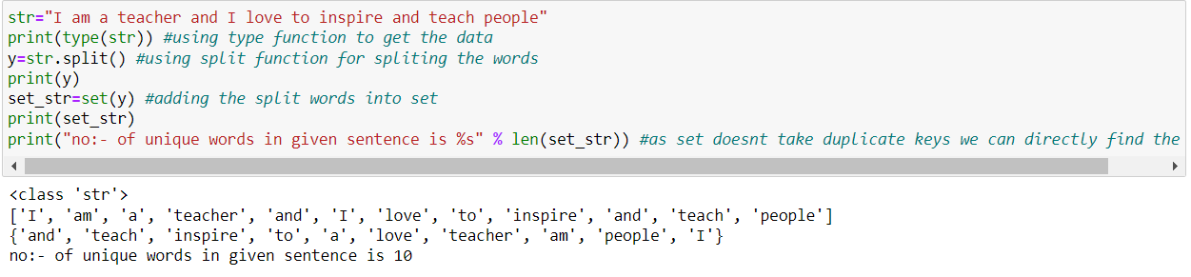

**Question 7**

Use a tab escape sequence to get the following lines. Name Age Country City Asabeneh 250 Finland Helsinki

**Source code:**

print('Name \tAge\tCountry\tCity')

print('Asabeneh 250\tFinland\tHelsinki') #using \t that using tab space to print the input in given format

**output:**

Name Age Country City

Asabeneh 250 Finland Helsinki

Process finished with exit code 0

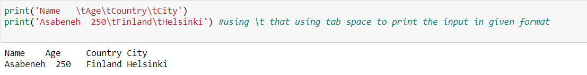

**Question 8**

Use the string formatting method to display the following: radius = 10 area = 3.14 * radius ** 2 “The area of a circle with radius 10 is 314 meters square.”

**Source code:**

radius=10

area=3.14*radius**2#using area formula to get the req value

sentence="The area of a circle with radius {} is {} meters square.".format(radius,int(area))

print(sentence)

**output:**

The area of a circle with radius 10 is 314 meters square.

Process finished with exit code 0

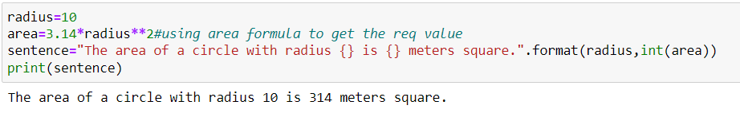

**Question 9**

Write a program, which reads weights (lbs.) of N students into a list and convert these weights to kilograms in a separate list using Loop. N: No of students (Read input from user) Ex: L1: [150, 155, 145, 148] Output: [68.03, 70.3, 65.77, 67.13]

**Source code:**

lb_kg_conversion= 0.45359237 #using lb to kg conversion

N=int(input('enter the number of students'))

L1=[]

for i in range(N):#running for loop from 0 to n that is number of students

L1.append(int(input('enter the element ')))

output=[lb_kg_conversion*i for i in L1 ]

print(output)

**output:**

enter the number of students4

enter the element 150

enter the element 155

enter the element 145

enter the element 148

[68.0388555, 70.30681735, 65.77089365, 67.13167076]

Process finished with exit code 0

